NOTE:
Please upgrade your radio to the latest firmware, then you can use these functions in the software.
The firmware Update contents:
a, Add the scan list in the radio Menu and software.
b, Add the group call match, private call match in the radio Menu and software.
c, Add the menu zone and edit zone in the radio Menu and software.
d, Add the Menu Hang time, can turn on/off in the in the radio Menu and software.
e, Fix the beidou serial port rate 9600 Module bug
Firmware description:
Following two are for the version of 10.000 contacts only
RT3S(GPS-REC)- S18.09.bin (start from S) for GPS version for RT3S GPS version
RT3S(REC)- D18.03.bin(start from D) for common version for RT3S No GPS version

Following two are for the version of 120.000 contacts
RT3S(CSV-GPS)- P18.09.bin(start from P) for GPS version for RT3S GPS version
RT3S(CSV)- V18.03.bin(start from V) for common version for RT3S No GPS version

Upgrade step:
Simultaneously press side key 1 and PTT key to turn on the radio, the indicator blinks and open upgraded software
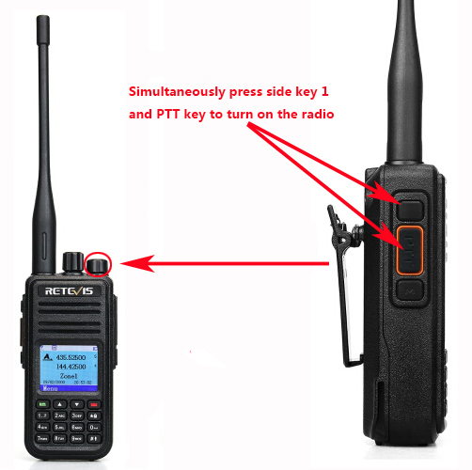
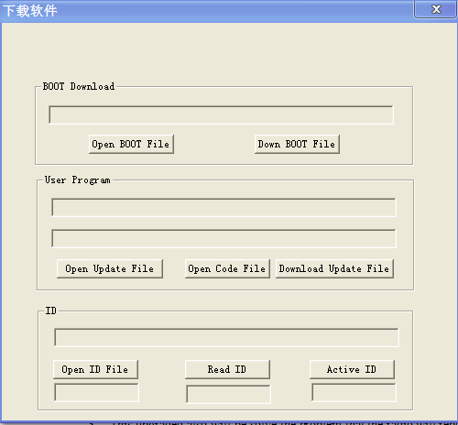

And then click the “Open Update File” button to select correct Update file，then click the “Download Update File” button to update, the radio will be upgraded as following:

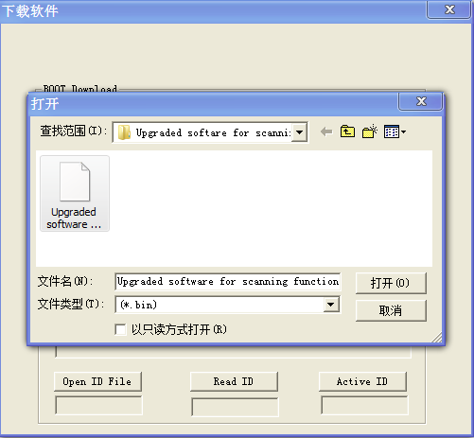

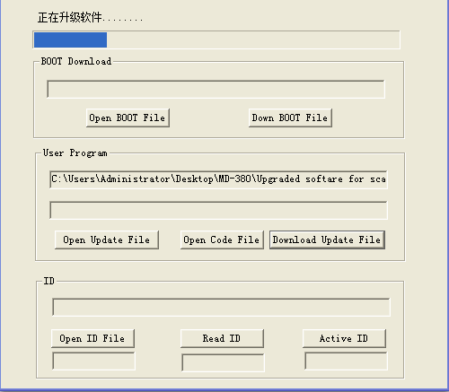

Software description:
1. Login to the official website：https://www.retevis.com/
2. Move the mouse to "SUPPORT" and select the drop-down menu "Resources", then find the RT3S programming software and firmware click to download
